

PuzzPak

Instruction Manual



Play computer games & compete in the highscores
with your friends!
GETTING STARTED:

Table of Contents. . . . . . . . . . . . . . . . . . . . . . . . . . . . . . . . . . . . . . . . . . . . . . . . . . . . . . . . . . . . . . . . . 2
Installation. . . . . . . . . . . . . . . . . . . . . . . . . . . . . . . . . . . . . . . . . . . . . . . . . . . . . . . . . . . . . . . . . . . . . . 3
Your Account. . . . . . . . . . . . . . . . . . . . . . . . . . . . . . . . . . . . . . . . . . . . . . . . . . . . . . . . . . . . . . . . . . . . 5
How to play: Hangman. . . . . . . . . . . . . . . . . . . . . . . . . . . . . . . . . . . . . . . . . . . . . . . . . . . . . . . . . . . . 6
How to play: Tik-Tak . . . . . . . . . . . . . . . . . . . . . . . . . . . . . . . . . . . . . . . . . . . . . . . . . . . . . . . . . . . . . 7
How to play: Memory Tiles . . . . . . . . . . . . . . . . . . . . . . . . . . . . . . . . . . . . . . . . . . . . . . . . . . . . . . . . 8
Post Rules & The Leaderboard . . . . . . . . . . . . . . . . . . . . . . . . . . . . . . . . . . . . . . . . . . . . . . . . . . . . . . 9
INSTALLATION
There are two methods of installing PuzzPak. One through the GUI and the other using the CLI. Both of these methods put the files in the same place.


PUZZPAK: USING A GUI:

1. Using any web browser, go to the URL https://github.com/reprise5/SeniorProject/ to download the application binaries from the Git repository reprise5/SeniorProject.
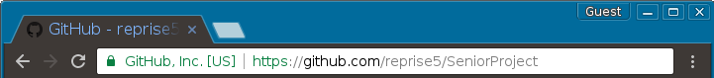
2. Then press the green [Clone or download] button at the right, then press “download zip”.

3. Go to your downloads folder, and unpack the zip file.

4. in the SeniorProject-master folder, copy and move the “dist” folder to wherever you desire. It is recommended this folder go into a folder called “games” or “documents” on your personal drive. You may also want to rename dist to “PuzzPak” for your own referencing purposes.

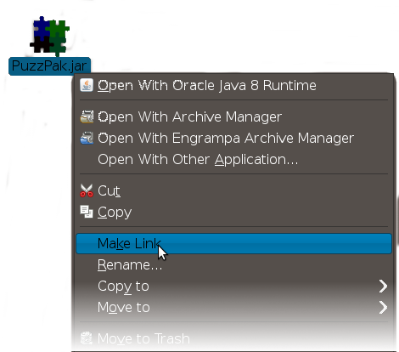
5. Lastly you will want to make a link on your desktop to the PuzzPak Executable. Right click the file named “PuzzPak.jar” and click “make link”

6. Put that new link on your desktop. It will reference the executable in your games folder.

7: Click the link on your desktop to begin playing.
PUZZPAK: USING the UNIX CLI:


Using the command line interface may be faster and more efficient in some ways, and some people may prefer this method. If you are installing PuzzPak this way, Please make sure you have a Graphical User Interface installed as well, because PuzzPak is not a command-based game package.

1: Open your preferred terminal application through any means.

2. First, download the application from the Git repository reprise5/SeniorProject using the Git command.

user@hostname $ git clone https://github.com/reprise5/SeniorProject/

3. Go to your downloads folder, and unzip the folder.

user@hostname $ cd Downloads/ && unzip SeniorProject-master.zip

4. move a copy of the dist folder to your Documents folder or your Games folder, and rename it to “puzzPak” at the same time.

user@hostname $ cd SeniorProject-master && cp -r dist ~/Games/PuzzPak

5. Create a symlink to PuzzPak's executable so you can have a copy on your desktop.

user@hostname $ cd ~/Games/PuzzPak/ && ln -s PuzzPak.jar ~/Desktop/PuzzPak


6. Press ctrl+d or type “exit” in your terminal to close it. Then click on the PuzzPak icon on your desktop to begin playing.

Oracle Java Runtime Environment 7

1. Please Visit : http://www.oracle.com/technetwork/java/javase/downloads/index.html

2. Find where it says [JRE] with a download button, and click on it. The package you download from this page is based on your Operating System and CPU architecture.

Package extension for Linux Types depend on your distribution. .rpm packages are for RHEL releases like Red Hat Enterprise Linux, Fedora, CentOS or distributions using the yum package manager. .deb packages are for any debian-based distribution, or one using the apt package manager. Tar.gz is a source package, and can be used to install the JRE to any distribution of Linux.

YOUR ACCOUNT

Creating and using your profile
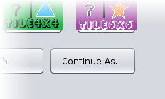
When you first open PuzzPak, you will notice a “Continue-as...” Button. This is button has multiple functions. If you don't log in, you will not be able to post any scores, though you can still play the games.

- If you're new:
  - type in your desired username. The program will make you a profile, and then save scores to that profile until you log out.
- If you're returning:
  - type in the username you made an account with in the past. You will continue as that user, and pick up where you left off.

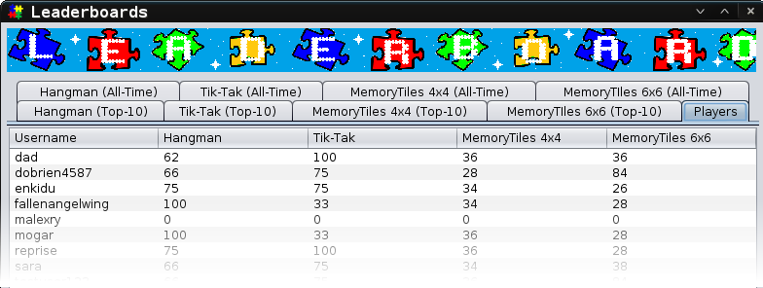
How your profile works

When you post a score, the system decides if your score in that game is higher than your previous attempt. If so, your score and the date you scored it on get updated. Your profile saves your top score for each game, which you can compare with everyone who has an account.
HOW TO PLAY: Hangman
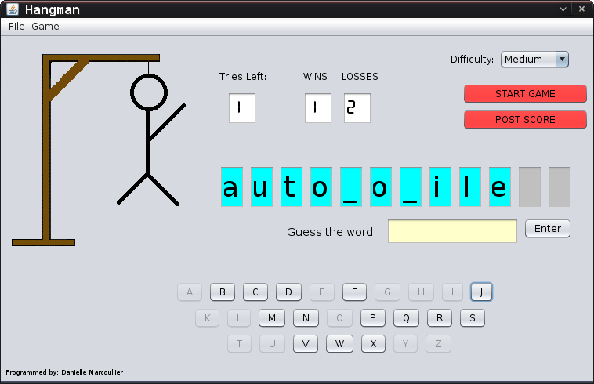

Starting a game
Hangman has 3 difficulties in the drop down menu, each of which has 25 different words. Once a difficulty is selected, a player must simply hit “start game” to initialize the game.

The easy difficulty has common short words, as well as longer words with many letters which make it more likely the player will guess right when picking a letter. The words also contain high-frequency letters like vowels, which are in almost every word.

The medium difficulty is the same as the easy difficulty, only the words are slightly less common, and have less unique letters which make it less likely the player will guess a correct letter.

The hard difficultly is filled with uncommon and long words, as well as words with low-frequency letters like x, z, q and y. if the player does guess the letters correctly, it is harder to extrapolate from the incomplete word to make an educated guess.

How To Win

In order to win, the player must guess the secret word by guessing letters that might be in the word.
If the guess is right, all instances of the guessed letter show up on the screen, and the player is allowed to guess another letter, or solve the puzzle.

There are two ways to input your guess to win. The first way is by pressing all the letter keys until the word is filled in (without losing the game), or by guessing the whole word in the text box. Making a wrong guess in the the text box will not penalize the player more than a key press.

If any guess is wrong, a piece of the hangman is drawn on the gallows. 6 wrong moves in total will cause the player to lose, thus ending the game. If the game ends, the missing letters fill in to reveal the hidden word the player was supposed to guess.
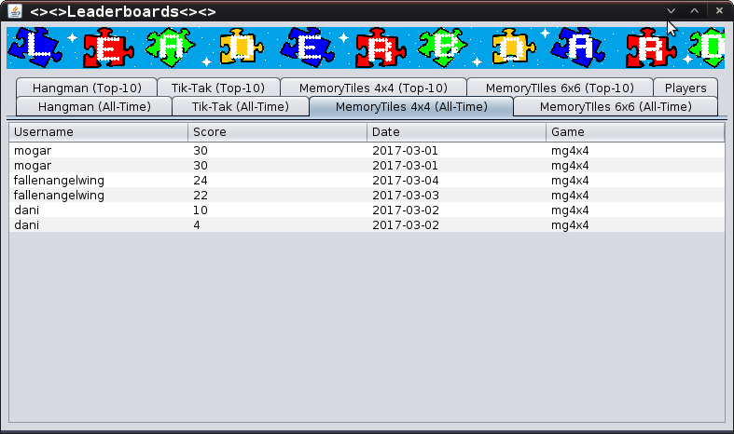
HOW TO PLAY: Tik-Tak
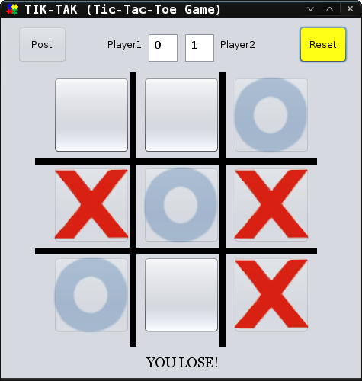

Player 2 getting a win with a right diagonal.

how to play
Tik-Tak is a clone of the classic game Tic-Tac-Toe, or Noughts & Crosses. Tik-Tak can be played by one player because a computer player acts as the opponent.

In order to start a game, a player will need to play their first move. The human player will always play red crosses (X), and the computer player will always play blue noughts (O).

The computer will think about their move, play it, then allow the human player to play another move. The human player cannot play a turn while the computer is thinking and playing their turn, and also may not play where a move has already been played.

How To Win
There are 8 ways to win which all follow the same principle: a player must get 3 of their own chips in a row. A player may get a win on the top row, middle row bottom row, left column, middle column, right column, or one of 2 diagonals.
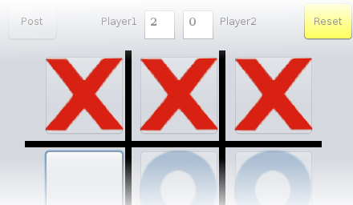

Player 1 getting a win on the top row.

Conversely, the human player can lose if their opponent gets 3 in a row with their chips in any of these 8 ways. If nobody gets 3 in a row, the game is simply a tie, and nobody gets a point.

HOW TO PLAY: MemoryTiles
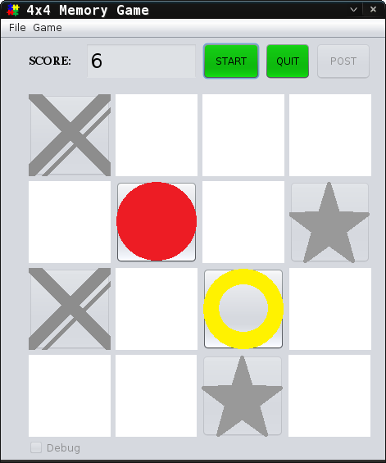

how to play
In order to start a new game, the “start” button needs to be pressed. This will randomize the board and put two of each kind of shape about the board. After clicking start game, the location of all the shapes appear on the board for about a second before flipping face down again. The objective of the game is to remember where all the pairs are, and match them.

To make a pair, click the first tile where your first guess is. This will show the first shape. To match that shape, the player must click the tile where they think it is. In order for the move to be valid, players must click on two distinct tiles. If the same tile is clicked twice, they are warned that it is against the rules. If the player continues to click the same tile twice, the game detects that the player is trying to gain an unfair edge to peek at the shapes without being penalized. The game will end itself.

How To Win
In order to win the game, players must match all of the shapes while keeping their score above 0. When a player pairs two shapes and they match, they are awarded with 5 points towards their score. The tiles then become disabled so they cannot be paired again after the player already got them right.

If the pair of shapes don't match, they are penalized by having 2 points removed from their score. Clicking a third blank tile will flip the two wrong ones face down from the previous matching. This makes it so the player has as much time as they want to leave the shapes showing to remember their location, and when they are ready to have them flip face down, they click the first tile of their next pairing.

4x4 vs 6x6 boards
The main difference between the 4x4 board and 6x6 board is that the 6x6 one is more of a challenge for those who seek it. The point system and rules for winning are the exact same. In addition, the 4x4 board shows the shapes for 0.8 seconds on start, while 6x6 shows them for 1.2 seconds.
POST RULES & THE LEADERBOARD

The Leaderboard

The leaderboard is where players' scores reside. The all time scoreboards show all of the scores from all players that have ever been recorded. The top 10 simply lists the top 10 reigning players with the highest scores. If two scores match, the person who got it first has a higher ranking. Each game has an All-Time scoreboard and a Top-10 scoregboard.

Hangman & TikTak

In order to be able to post to games that keep track of score using wins and losses, The player must play a minimum of three games in order to be able to post their score. Their score will be the percentage of games that the user won.

Memory Tiles

Memory Tiles 4x4 and 6x6 have the same scoring methods and posting rules. When a player makes a correct match, they are awarded 5 points. If the match is incorrect, they are penalized 2 points. If a player's score is greater than 0 at the end of the game when the user matches all the shapes on the board, they will be allowed to post their score. The maximum score for 4x4 is 40, where the maximum score in 6x6 is 90.

